CMDA3634 HW03

Shirong Kou

Q 0.1 and 0.2

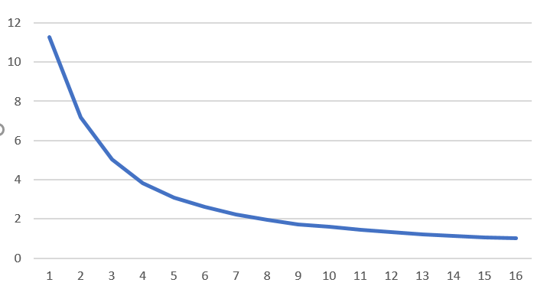

When there are more threads, the run time will reduce.

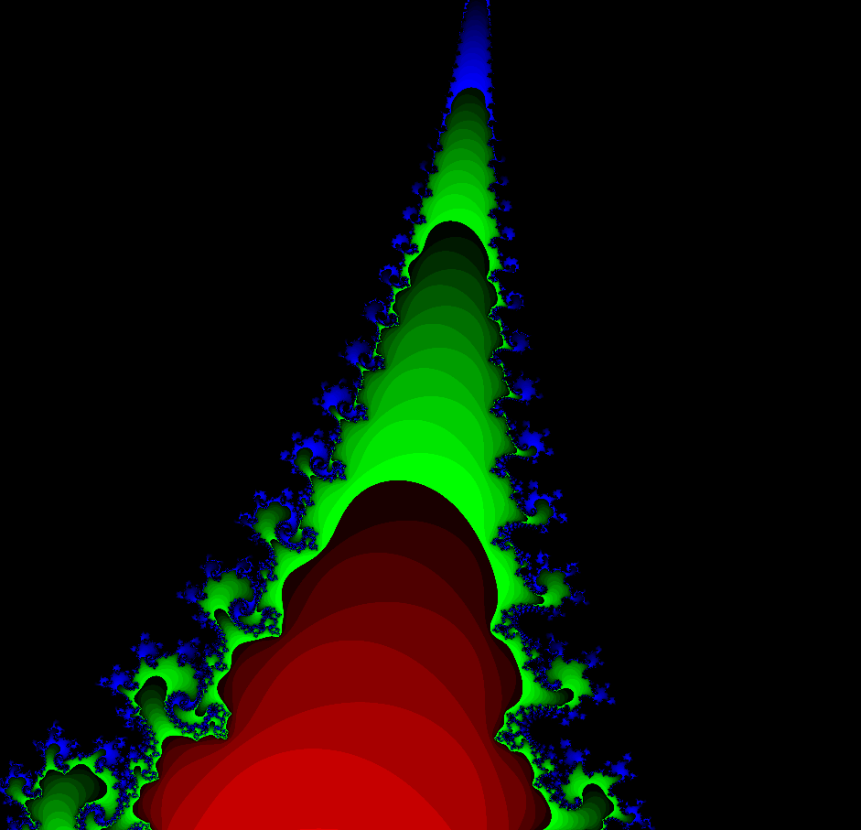

This is a Mandelbrot imagine.